**HOMEWORK 5**

**Họ và tên: Nguyễn Huỳnh Trúc Thanh**

**MSSV: N20DCCN142**

**1.**

**a.**

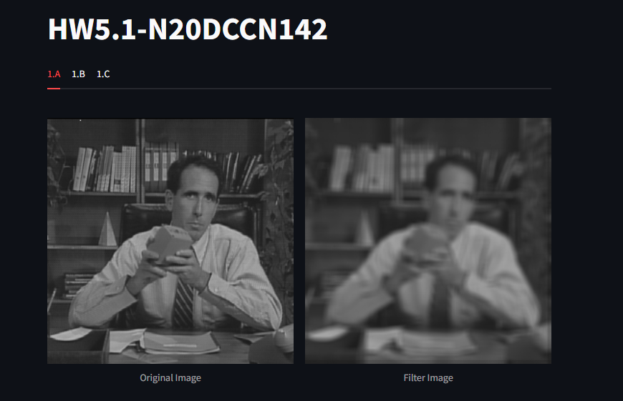

**b.** 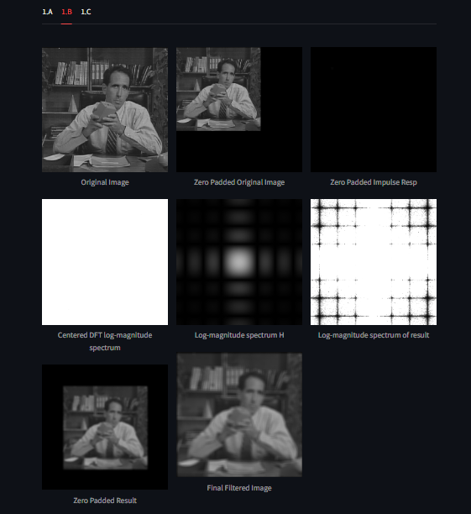

**c.**

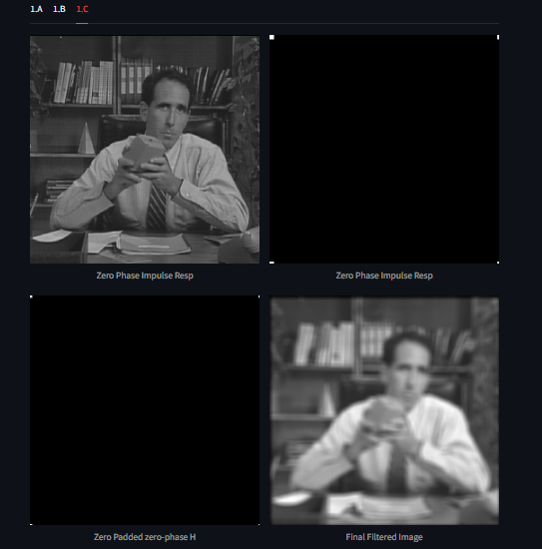

**2.**

**a.**

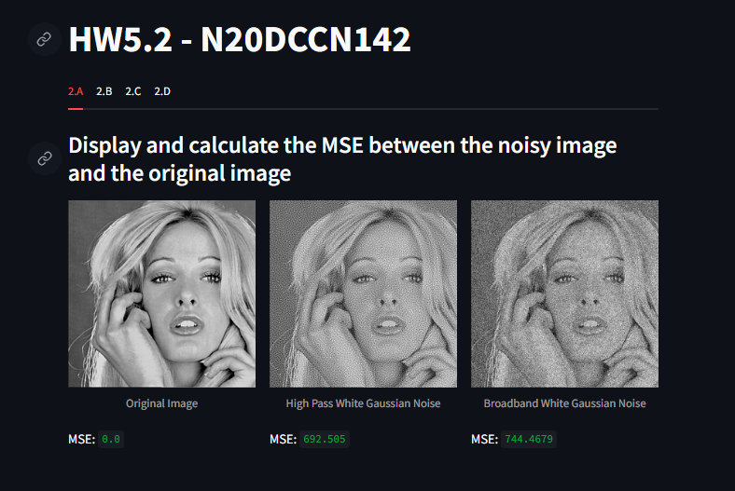

**b.**

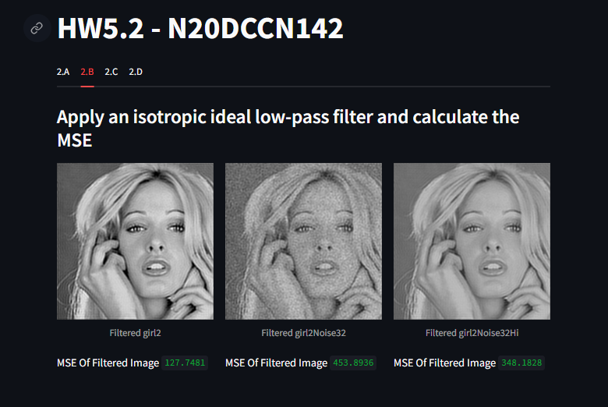

**c.**

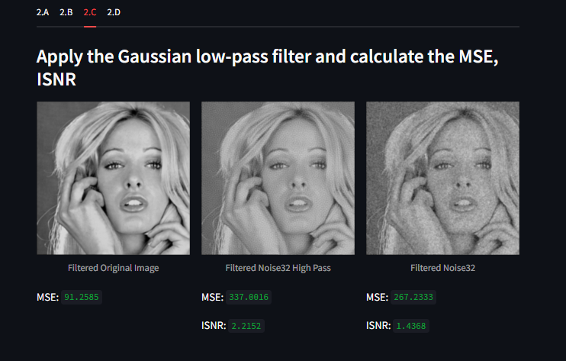

**d.**

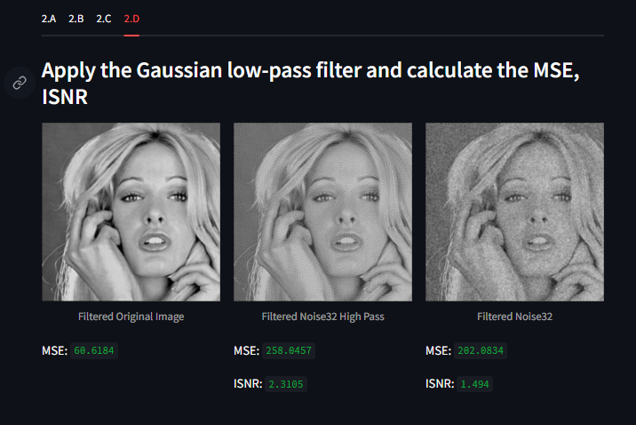

**Link github:** [**https://github.com/NHT2-gh/Image_Processing.git**](https://github.com/NHT2-gh/Image_Processing.git)